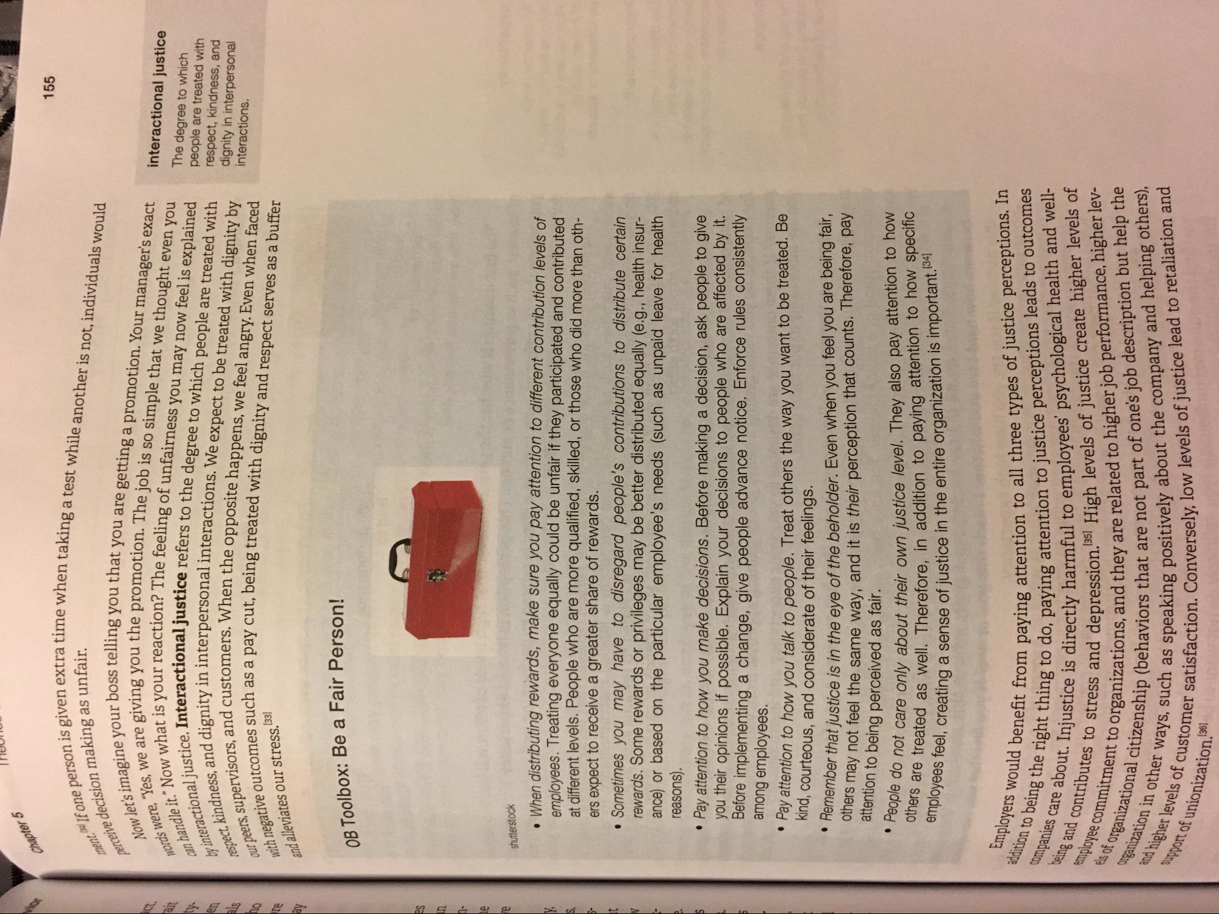
Chapter 5
155
nt al If one person is given
perceive decisio
a time when taking a test while another is not, individuals would
can handle it.”N
ve decision making as unfair. Now let's imagine your boss to ds were, "Yes, we are giving you
ndle it." Now what is your reac teractional justice. Interaction: spect, kindness, and dignity in i
neers, supervisors, and customers with negative outcomes such as and alleviates our stress. [33]
by interactional just
Westelling you that you are getting a promotion. Your manager's exact in vou the promotion. The job is so simple that we thought even you
ir reaction? The feeling of unfairness you may now feel is explained national justice refers to the degree to which people are treated with sin interpersonal interactions. We expect to be treated with dignity by istomers. When the opposite happens, we feel angry. Even when faced has a pay cut, being treated with dignity and respect serves as a buffer
interactional justice The degree to which people are treated with respect, kindness, and dignity in interpersonal interactions.
OB Toolbox: Be a Fair Person!
shutterstock
When distributing rewards, make sure you pay attention to different contribution levels of emplovees. Treating everyone equally could be unfair if they participated and contributed at different levels. People who are more qualified, skilled, or those who did more than oth
ers expect to receive a greater share of rewards. • Sometimes you may have to disregard people's contributions to distribute certain rewards. Some rewards or privileges may be better distributed equally (e.g., health insurance) or based on the particular employee's needs (such as unpaid leave for health reasons). • Pay attention to how you make decisions. Before making a decision, ask people to give
you their opinions if possible. Explain your decisions to people who are affected by it. Before implementing a change, give people advance notice. Enforce rules consistently among employees. Pay attention to how you talk to people. Treat others the way you want to be treated. Be kind, courteous, and considerate of their feelings. member that justice is in the eye of the beholder. Even when you feel you are being fair,
may not feel the same way, and it is their perception that counts. Therefore, pay attention to being perceived as fair.
Hol care only about their own iustice level. They also pay attention to how weated as well. Therefore, in addition to paying attention to how specific
". Creating a sense of justice in the entire organization is important. (34)
• Remen
others
• People do not care only ab others are treated as we employees feel, creating a sense
Employers would benefit from payin
addition to being the
being the right thing to do, paying attention to
les care about. Injustice is dire
companies care being and contribu
Lent from paying attention to all three types of justice perceptions. In
to do, paying attention to justice perceptions leads to outcomes olice is directly harmful to employees' psychological health and well
ss and depression.35) High levels of justice create higher levels of Sanizations, and they are related to higher job performance, higher lev
P (behaviors that are not part of one's job description but help the s, such as speaking positively about the company and helping others)
tisfaction. Conversely, low levels of justice lead to retaliation and
contributes to stress and depression.
els of organiza
vers).
inployee commitment to organi
organizational citizenship (ben anization in other ways, suc
gher levels of customer satisfact
and higher leve
upport of unionization.

